01

HTML

oubt clearing sessions. I use the study material they HTML Interview Questions and Answers

**Contents**

1. Are the HTML tags and elements the same thing?
2. What are tags and attributes in HTML?
3. What are void elements in HTML?
4. What is the advantage of collapsing white space?
5. What are HTML Entities?
6. What are different types of lists in HTML?
7. What is the ‘class’ attribute in HTML?
8. What is the difference between the ‘id’ attribute and the ‘class’ attribute of HTML elements?
9. Define multipart form data?
10. Describe HTML layout structure.
11. How to optimize website assets loading?
12. What are the various formatting tags in HTML?
13. What are the different kinds of Doctypes available?
14. Please explain how to indicate the character set being used by a document in HTML?
15. What is the difference between **, tags and *, tags?***
16. ***What is the significance of and tag in HTML?***
17. ***Can we display a web page inside a web page or Is nesting of webpages possible?***
18. ***How is Cell Padding diﬀerent from Cell Spacing?***
19. ***How can we club two or more rows or columns into a single row or column in an HTML table?***

***20. Is it possible to change an inline element into a block level element?***

[***HTML Interview Questions***](https://www.interviewbit.com/html-interview-questions/)



1. ***In how many ways can we position an HTML element? Or what are the permissible values of the position attribute?***
2. ***In how many ways you can display HTML elements?***
3. ***What is the diﬀerence between “display: none” and “visibility: hidden”, when used as attributes to the HTML element.***
4. ***How to specify the link in HTML and explain the target attribute?***
5. ***In how many ways can we specify the CSS styles for the HTML element?***
6. ***Diﬀerence between link tag and anchor tag ?***
7. ***How to include javascript code in HTML?***
8. ***When to use scripts in the head and when to use scripts in the body?***
9. ***What are forms and how to create forms in HTML?***
10. ***How to handle events in HTML?***

**Page 5** © Copyright by Interviewbit

[**HTML Interview Questions**](https://www.interviewbit.com/html-interview-questions/)



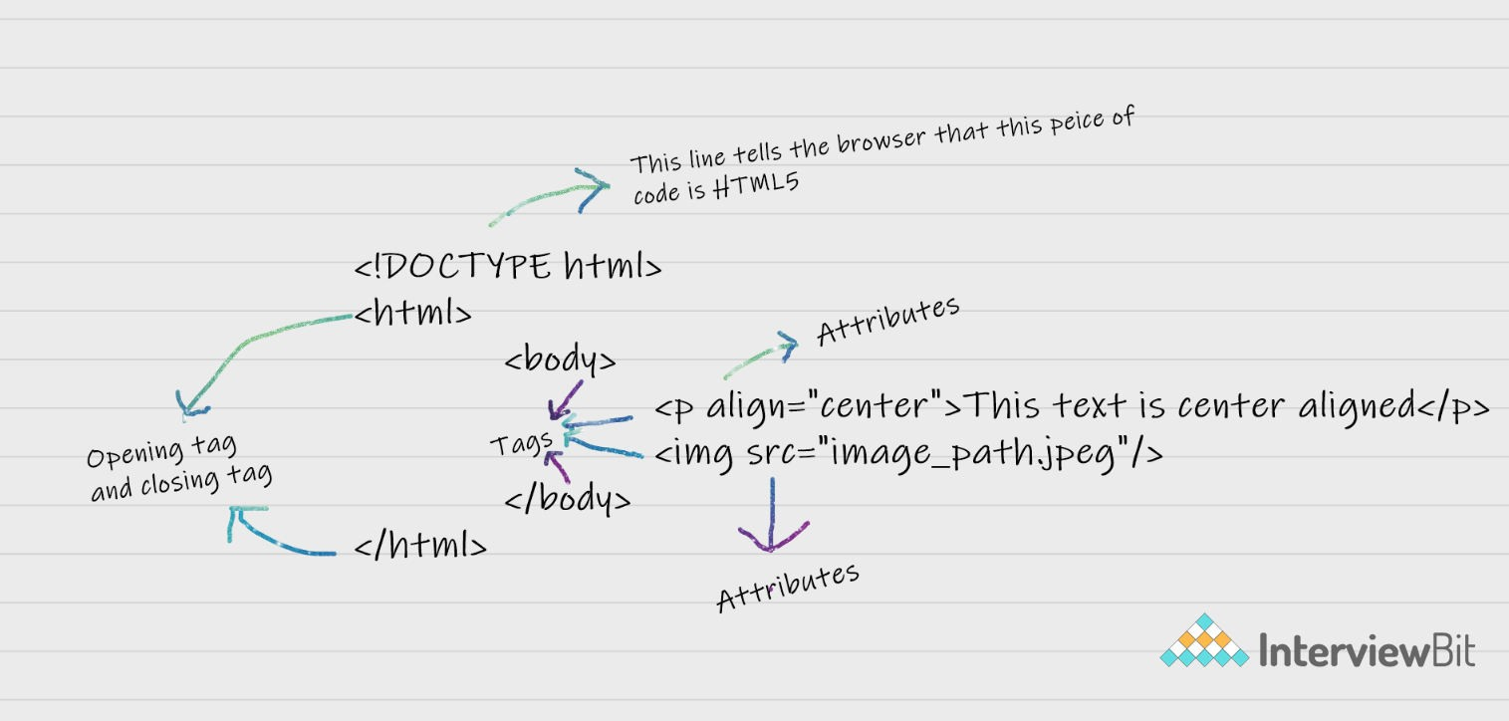

**HTML Interview Questions and Answers**

### Are the HTML tags and elements the same thing?

No. HTML elements are defined by a starting tag, may contain some content and a closing tag.For example, <h1>Heading 1</h1> is a HTML element but just <h1> is a starting tag and </h1> is a closing tag.

### What are tags and attributes in HTML?

Tags are the primary component of the HTML that defines how the content will be structured/ formatted, whereas Attributes are used along with the HTML tags to define the characteristics of the element. For example, <p align=” center”>Interview questions</p>, in this the ‘align’ is the attribute using which we will align the paragraph to show in the center of the view.

### What are void elements in HTML?

HTML elements which do not have closing tags or do not need to be closed are Void elements. For Example <br />, <img />, <hr />, etc.

### What is the advantage of collapsing white space?

In HTML, a blank sequence of whitespace characters is treated as a single space character, Because the browser collapses multiple spaces into a single space character and this helps a developer to indent lines of text without worrying about multiple spaces and maintain readability and understandability of HTML codes.

[**HTML Interview Questions**](https://www.interviewbit.com/html-interview-questions/)

### What are HTML Entities?

In HTML some characters are reserved like ‘<’, ‘>’, ‘/’, etc. To use these characters in our webpage we need to use the character entities called HTML Entities. Below are a few mapping between the reserved character and its respective entity character to be used.

**Character Entity Name Entity Number**

< &lt; &#60;

> &gt; &#62;

& &amp; &#38; (non-

breaking space) Eg. 10 PM

&nbsp; Eg.

<p>10&nbsp&nbspPM</p>

&#160;

**Page 7** © Copyright by Interviewbit

### What are the different types of lists in HTML?

[**HTML Interview Questions**](https://www.interviewbit.com/html-interview-questions/)



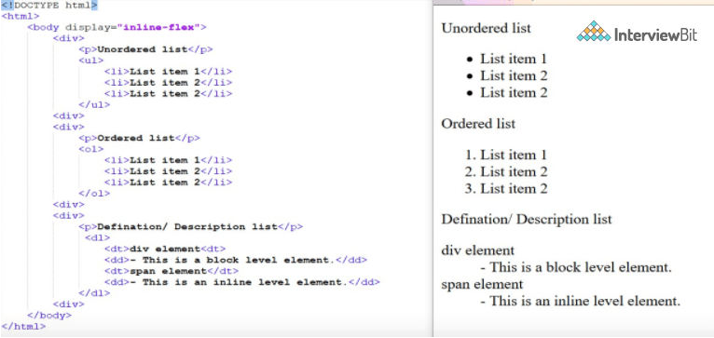

1. **What is the ‘class’ attribute in HTML?**

The class attribute is used to specify the class name for an HTML element. Multiple elements in HTML can have the same class value. Also, it is mainly used to associate the styles written in the stylesheet with the HTML elements.

### What is the diﬀerence between the ‘id’ attribute and the ‘class’ attribute of HTML elements?

Multiple elements in HTML can have the same class value, whereas a value of id attribute of one element cannot be associated with another HTML element.

### Define multipart form data?

Multipart form data is one of the values of the enctype attribute. It is used to send the file data to the server-side for processing. The other valid values of the enctype attribute are text/plain and application/x-www-form-urlencoded.

### Describe HTML layout structure.

Every web page has different components to display the intended content and a specific UI. But still, there are few things which are templated and are globally accepted way to structure the web page, such as:

**Page 8** © Copyright by Interviewbit

**Page 9** © Copyright by Interviewbit

**<header>**: Stores the starting information about the web page.

[**HTML Interview Questions**](https://www.interviewbit.com/html-interview-questions/)



**<footer>**: Represents the last section of the page.

**<nav>**: The navigation menu of the HTML page.

**<article>**: It is a set of information.

**<section>**: It is used inside the article block to define the basic structure of a page.

**<aside>**: Sidebar content of the page.

### How to optimize website assets loading?

To optimize website load time we need to optimize its asset loading and for that:

**CDN hosting** - A CDN or content delivery network is geographically distributed servers to help reduce latency.

**File compression** - This is a method that helps to reduce the size of an asset to reduce the data transfer

**File concatenation** - This reduces the number of HTTP calls

**Minify scripts** - This reduces the overall file size of js and CSS files

**Parallel downloads** - Hosting assets in multiple subdomains can help to bypass the download limit of 6 assets per domain of all modern browsers. This can be configured but most general users never modify these settings.

**Lazy Loading** - Instead of loading all the assets at once, the non-critical assets can be loaded on a need basis.

### What are the various formatting tags in HTML?

HTML has various formatting tags:

**<b>** - makes text bold

[**HTML Interview Questions**](https://www.interviewbit.com/html-interview-questions/)



**<i>** - makes text italic

**<em>** - makes text italic but with added semantics importance

**<big>** - increases the font size of the text by one unit

**<small>** - decreases the font size of the text by one unit

**<sub>** - makes the text a subscript

**<sup>** - makes the text a superscript

**<del>** - displays as strike out text

**<strong>** - marks the text as important

**<mark>** - highlights the text

**<ins>** - displays as added text

### What are the diﬀerent kinds of Doctypes available?

The three kinds of Doctypes which are available: Strict Doctype

Transitional Doctype Frameset Doctype

### Please explain how to indicate the character set being used by a document in HTML?

The character set is defined in <meta> tag inside <head> element.

<!DOCTYPE **html**>

<**html**>

<**head**>

<**meta** charset="UTF-8">

...

...

</**head**>

...

</**html**>

### What is the diﬀerence between , tags and *, tags?*

***The eﬀect on a normal webpage of the tags <strong>, <b> and <em>, <i> is the same. <b> and <i> tags stands for bold and italic. These two tags only apply font styling and bold tag <b>, just adds more ink to the text, these tags don't say***

***anything about the text.***

**Page 10** © Copyright by Interviewbit

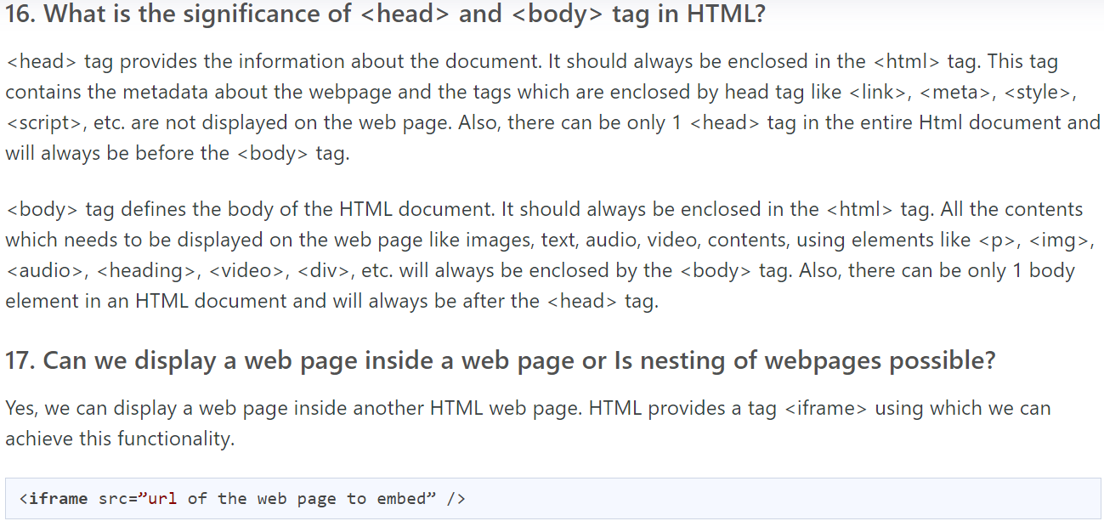

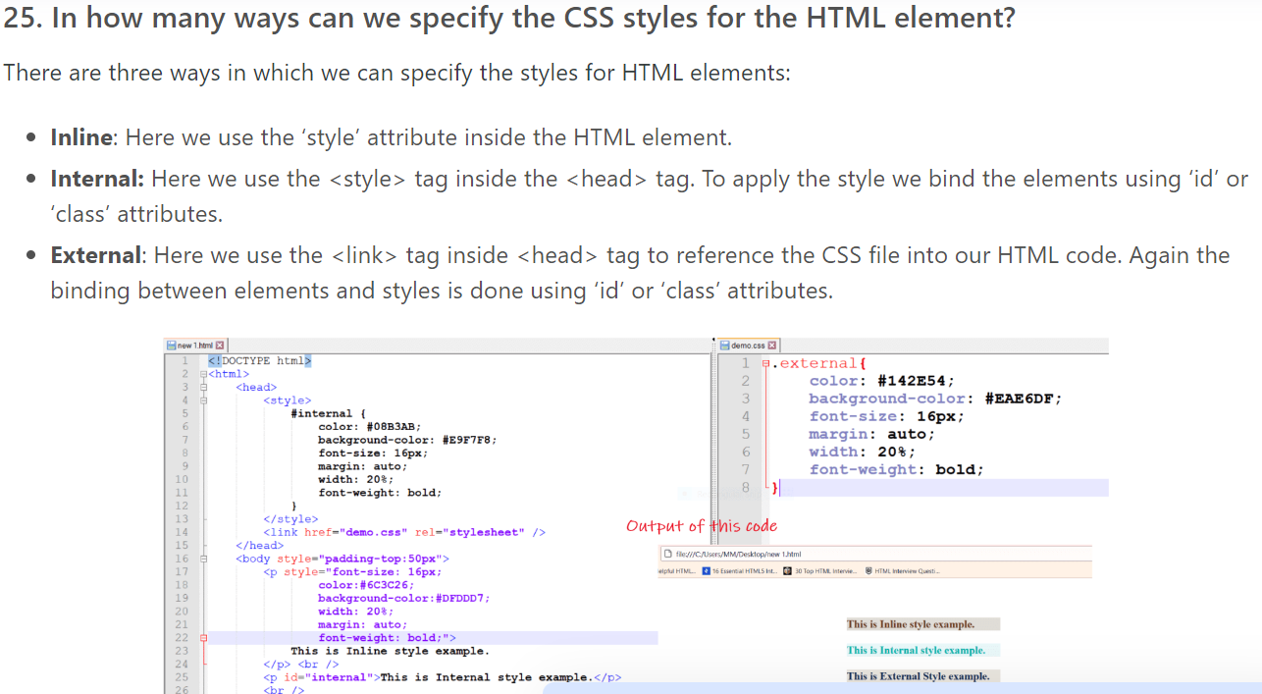

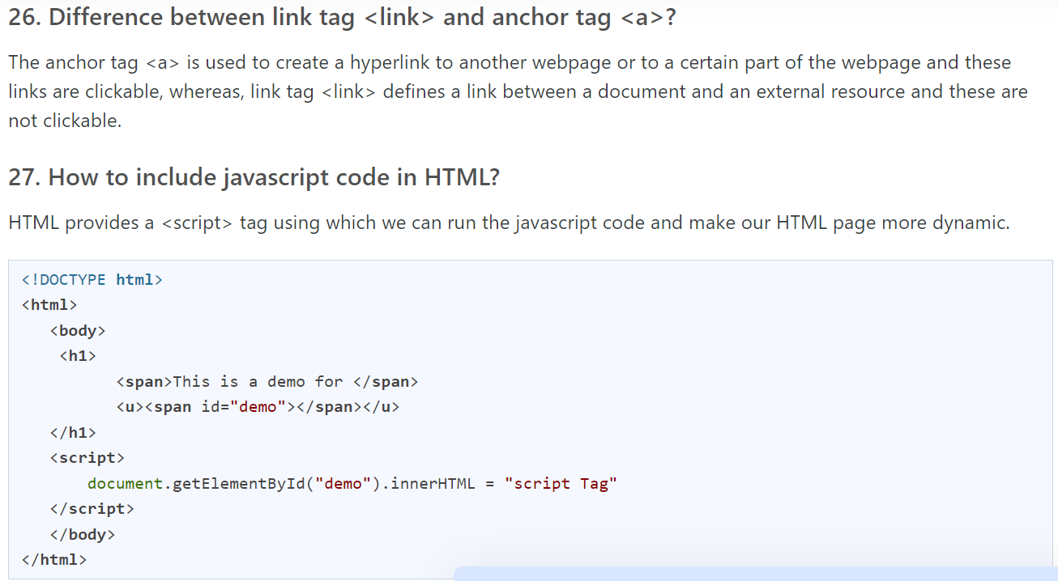

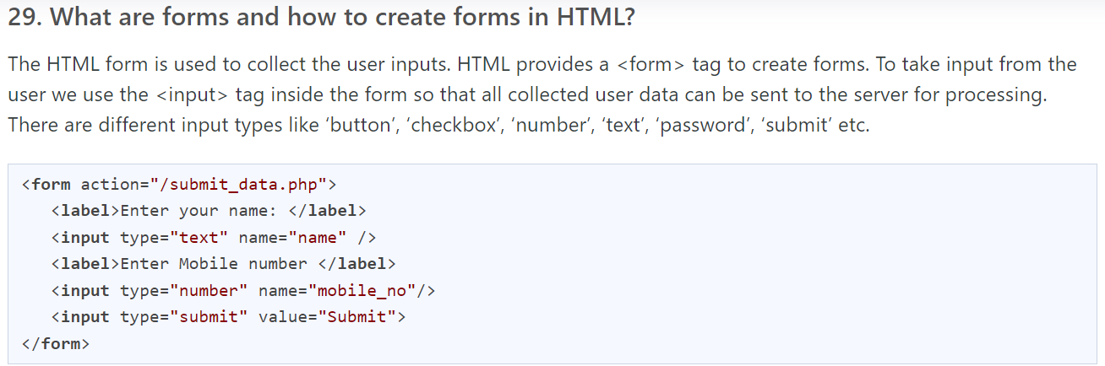

HTML5

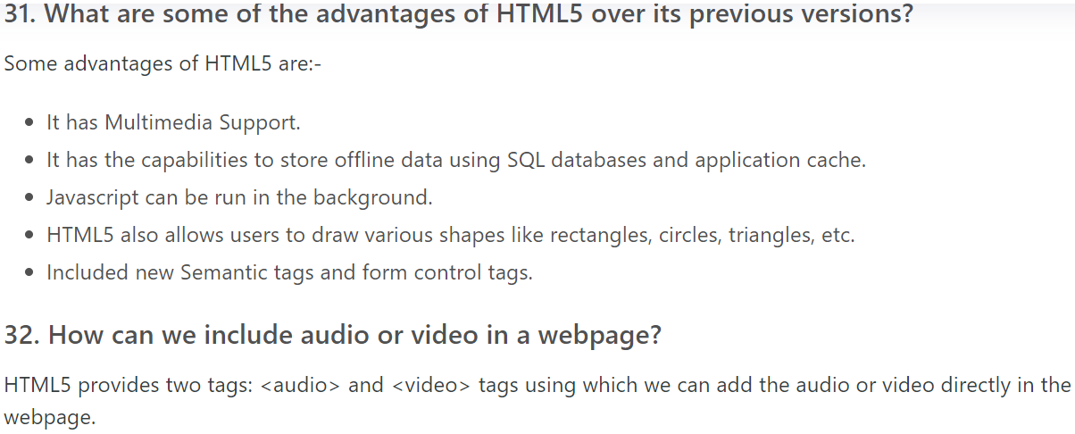

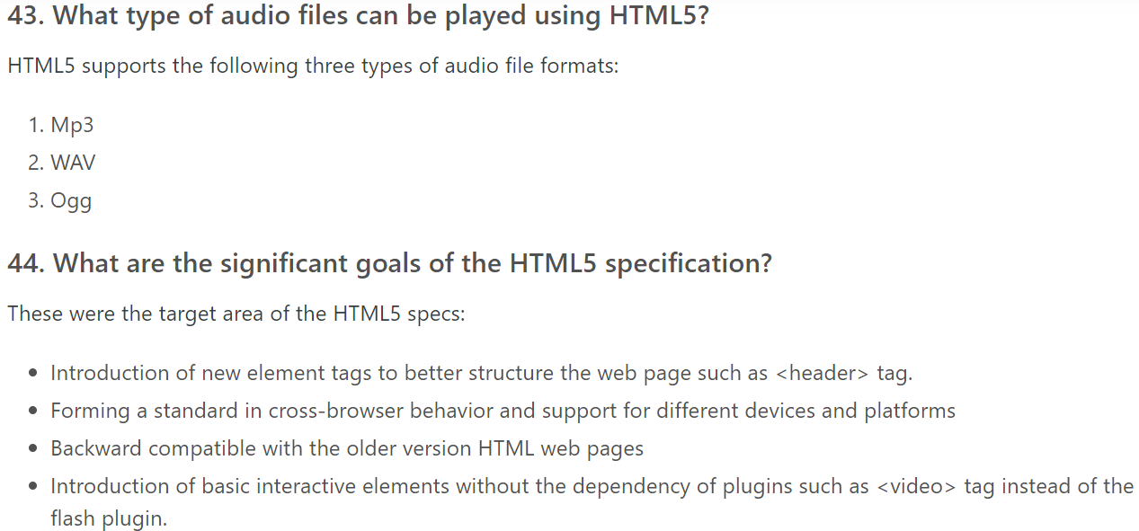

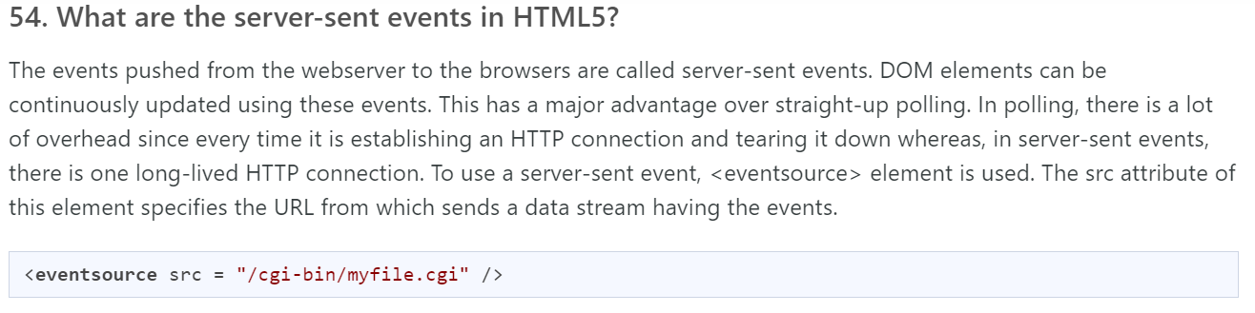

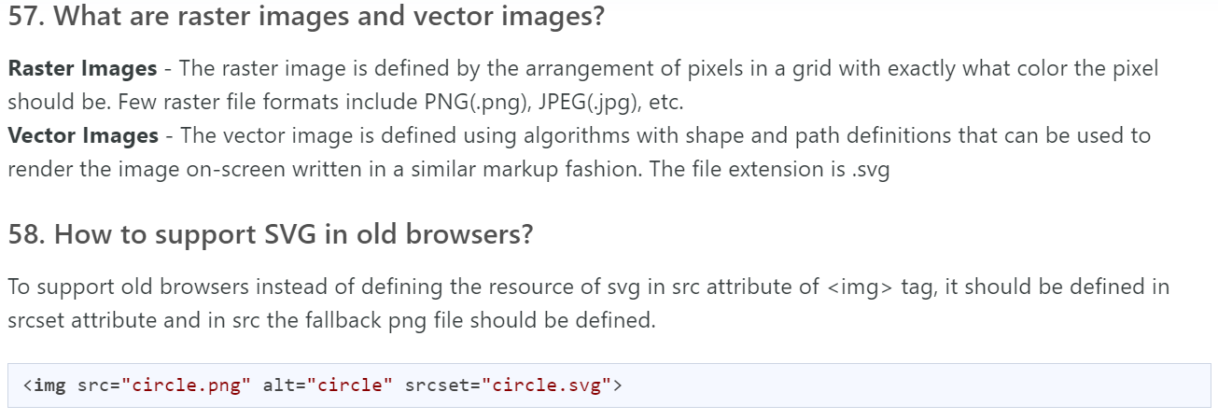

ALL THE BEST!!!